**Experiment No. 11**

**Aim : -** Case Study: GitHub for version control.

**Theory : -**

Whenever a software is built, there is always scope for improvement and those improvements brings changes in picture. Changes may be required to modify or update any existing solution or to create a new solution for a problem. Requirements keeps on changing on daily basis and so we need to keep on upgrading our systems based on the current requirements and needs to meet desired outputs. Changes should be analyzed before they are made to the existing system, recorded before they are implemented, reported to have details of before and after, and controlled in a manner that will improve quality and reduce error. This is where the need of System Configuration Management comes. System Configuration Management (SCM) is an arrangement of exercises which controls change by recognizing the items for change, setting up connections between those things, making/characterizing instruments for overseeing diverse variants, controlling the changes being executed in the current framework, inspecting and revealing/reporting on the changes made. It is essential to control the changes in light of the fact that if the changes are not checked legitimately then they may wind up undermining a well-run programming. In this way, SCM is a fundamental piece of all project management activities.

Processes involved in SCM – Configuration management provides a disciplined environment for smooth control of work products. It involves the following activities:

1. Identification and Establishment – Identifying the configuration items from products that compose baselines at given points in time (a baseline is a set of mutually consistent Configuration Items, which has been formally reviewed and agreed upon, and serves as the basis of further development). Establishing relationship among items, creating a mechanism to manage multiple level of control and procedure for change management system.

2. Version control – Creating versions/specifications of the existing product to build new products from the help of SCM system.

3. Change control – Controlling changes to Configuration items (CI).

4. A change request (CR) is submitted and evaluated to assess technical merit, potential side effects, overall impact on other configuration objects and system functions, and the projected cost of the change. The results of the evaluation are presented as a change report, which is used by a change control board (CCB) —a person or group who makes a final decision on the status and priority of the change. An engineering change Request (ECR) is generated for each approved change. Also, CCB notifies the developer in case the change is rejected with proper reason. The ECR describes the change to be made, the constraints that must be respected, and the criteria for review and audit. The object to be changed is “checked out” of the project database, the change is made, and then the object is tested again. The object is then “checked in” to the database and appropriate version control mechanisms are used to create the next version of the software.

5. Configuration auditing – A software configuration audit complements the formal technical review of the process and product. It focuses on the technical correctness of the configuration object that has been modified. The audit confirms the completeness, correctness, and consistency of items in the SCM system and track action items from the audit to closure.

6. Reporting – Providing accurate status and current configuration data to developers, tester, end users, customers and stakeholders through admin guides, user guides, FAQs, Release notes, Memos, Installation Guide, Configuration guide etc.

System Configuration Management (SCM) is a software engineering practice that focuses on managing the configuration of software systems and ensuring that software components are properly controlled, tracked, and stored. It is a critical aspect of software development, as it helps to ensure that changes made to a software system are properly coordinated and that the system is always in a known and stable state.

SCM involves a set of processes and tools that help to manage the different components of a software system, including source code, documentation, and other assets. It enables teams to track changes made to the software system, identify when and why changes were made, and manage the integration of these changes into the final product.

Some GitHub features are:

• Commit

• Graphs

• Pull requests

• Issue Tracking

• Email notifications

Example –

Git Version Control

Git is software for tracking changes in any set of files, usually used for coordinating work among programmers collaboratively developing source code during software development. Its goals include speed, data integrity, and support for distributed, non-linear workflows (thousands of

parallel branches running on different systems). Git was created by Linus Torvalds in 2005 for development of the Linux kernel, with other kernel developers contributing to its initial development. Since 2005, Junio Hamano has been the core maintainer. As with most other

distributed version control systems, and unlike most client–server systems, every Git directory on every computer is a full-fledged repository with complete history and full version-tracking

abilities, independent of network access or a central server. Git is free and open-source software distributed under GNU General Public License Version 2.

Some git commands:

• Add commands:

$ git add File-name

• Add all files in specific directory to staging area:

$ git add –all

$ git add docs/*.txt

• Committing changes:

$ git commit -m "Add existing file"

• Pushing changes:

$ git push -u origin main

• Pulling changes:

$ git pull

**Output : -**

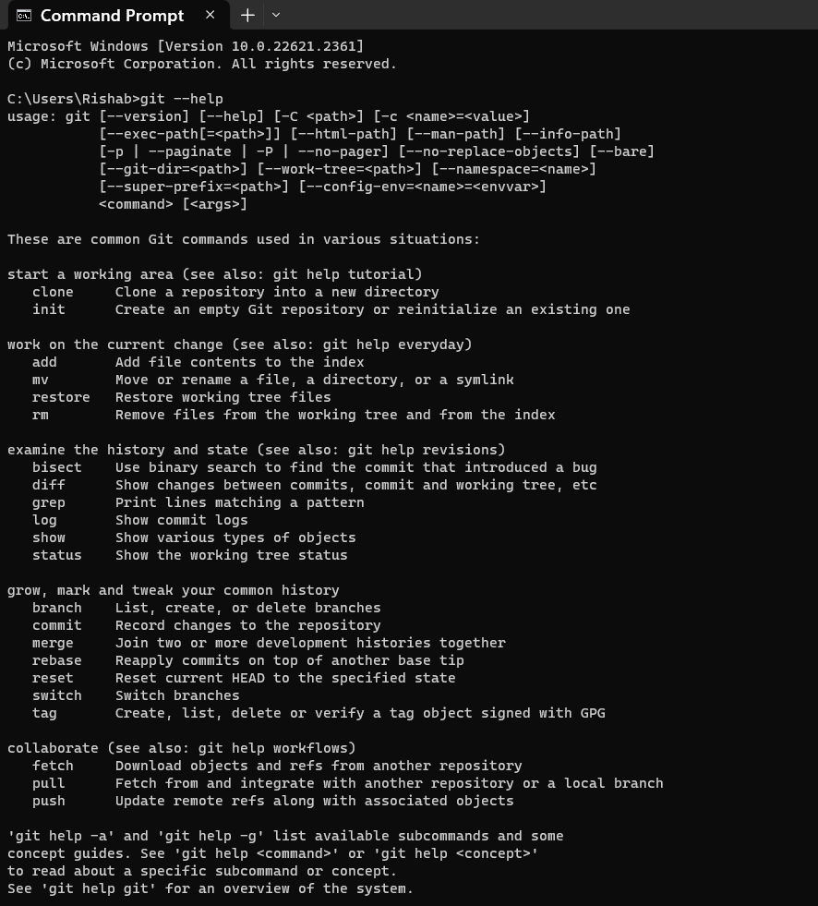

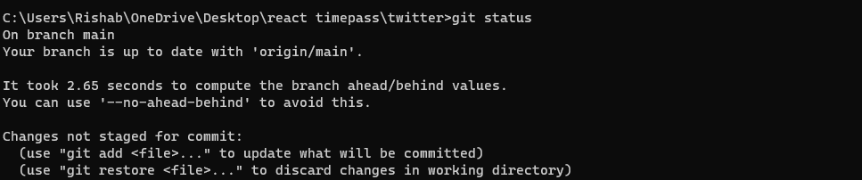

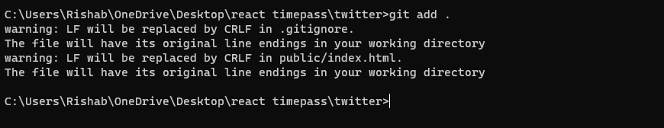

**Conclusion : -**

Hence, we have understood the implementation and use of GitHub for our given project.